Experiential Learning

What is ‘Experiential Learning’?

Experiential Learning is the process of learning through experience. It can be more specifically defined as ‘learning something through reflection on doing it’. The idea of learning through experience has been around for a very long time and dates back to the time of Aristotle. David Kolb began to articulate the idea as an educational approach in the 1970’s, drawing on the work of John Dewy, Kurt Lewin and Jean Piaget. Kolb’s ideas have been further developed, and applied to a number of things, such as models, including those of Graham Gibbs (1988) and Jennifer Moon (2004).

What is the ‘Experiential Learning Cycle’?

The experiential learning cycle involves four stages: ‘Concrete Experience’ (CE), ‘Reflective Observation’ (RO), ‘Abstract Conceptualisation’ (AC) and ‘Active Experimentation’ (AE), which are linked together in a cycle, (see figure below). Learning happens when someone moves through each of these four ‘poles’. They may enter the cycle at any pole, but if they enter at the CE pole this is particularly conducive to learning.

The CE pole represents the encounter of an experience. This is followed by the RO pole, which represents the person thinking back on what the experience was like. After this comes the AC pole. Here, the person draws on their reflections to form new ideas about the experience, or to modify their existing ideas about it. The final pole is AE, which is where the learner makes plans about how they will apply their new ideas to their next experience. This cycle can happen over a short or long period of time. Since, with each cycle, the person is at a ‘higher’ level of learning, the process becomes more like a spiral than a cycle.

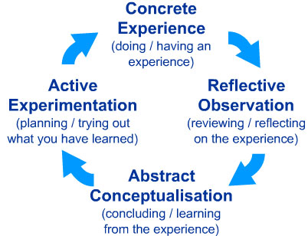

Why, and how, do I apply this ‘cycle’ to my teaching?

There are several ways that the experiential learning cycle can be applied when we plan our teaching. Firstly, we can try to construct our session such that the learners will, at least briefly, touch on as many of the poles of the cycle as possible during our teaching session. This might seem easier in some learning environments, (eg simulation), than others, (eg large lectures). However even in lectures, where learners can often sit at the ‘AC’ pole, there are ways we can help move them around the cycle a bit more, for example by incorporating short pair-work activities or building in opportunities to deliberately pause and think about things A second application of the cycle is that it is a helpful reminder that individual learners have different learning preferences. This means that, if left to their own devices, they would usually engage with learning materials in a limited number of ways. For example, some people find they are particularly good at, and enjoy, thinking abstractly about things, so they tend to do this rather than more actively engaging with learning materials. Others are the opposite way inclined. In a group of learners, there will be a mix of these preferences. So, if we try to address every pole of the cycle during a teaching session, we will be appealing to a much larger cohort of the learner group.

References:
Gibbs, G. (1988). Learning by doing: a guide to teaching and learning methods. Oxford: Further Education Unit, Oxford Brookes University.
Kolb, D. (1884). Experiential Learning as the Science of Learning and Development. Englewood Cliffs, New Jersey: Prentice Hall.
Moon, J. (2004) A Handbook of Reflective and Experiential Learning: theory and Practice. London: RouteledgeFalmer.

